1 Write the css on the following transformation.

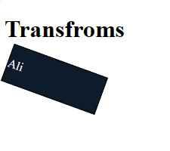

2. Design box model using css3

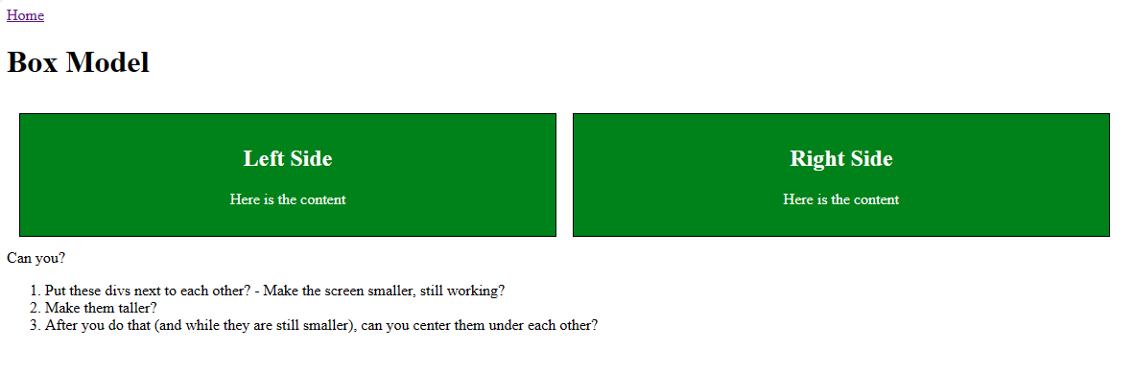

3. Implement gradient

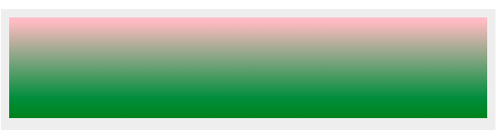

4. **Implement CSS Transitions:**

* Apply CSS transitions to create smooth effects when hovering over links, buttons, or images.
* Experiment with different transition properties such as **transition-property**, **transition-duration**, and **transition-timing-function**